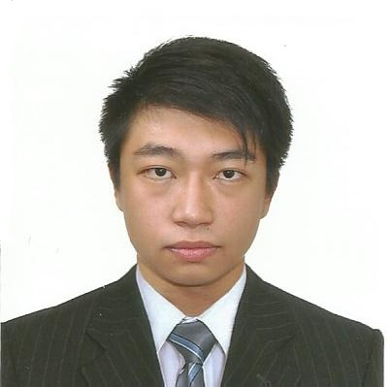

KARL AURELIUS F. SYKIOCO
____________________________________________________________________________PERSONAL INFORMATION

Age: 24 y/o Height/Weight: 163cm/77kg
Citizenship: Filipino Civil Status: Single
Religion: Roman Catholic
Address: 21 E.P. Mariano St., Ususan Taguig City
Contact Numbers: (02) 642-6943, +63 917 318 1194, 0961 132 2912
E-mail address: karl.sykioco@gmail.com, karlsykioco@live.com
Social Networking: Facebook: TheGreatKarlSykioco Twitter: @KSykioco

____ OBJECTIVE

- To apply for a job at a well-reputed company; obtaining experience that could help and maximize the company’s growth through my skills, knowledge, and abilities as a global competitor.

WORK EXPERIENCE

- Ingram Micro Philippines LLC (July 2017-Present)
- Support Rep 1 – Commerce and Lifecycle Services Order Management Team
– Received awards including employee of the month for January 2019
- Encore Engagement Team (January 2018 – December 2018)
- Greenfield Marketer’s One/Greenfield Development Corporation (March 2016-August 2016)
- Property Consultant(Sales Agent)
- Transcom Worldwide Philippines (April 2015 – November 2015)
  - Customer Service and Billing – TalkTalk Mobile Department
  - Logistics Operations(Back-office)- TalkTalk Provisioning Team

EDUCATIONAL BACKGROUND
- Tertiary: Bachelor of Science in Business Administration major in Marketing Management
  - University of the East
  - June 2011 – 2012. 2014 - 2015
- Secondary Education
  - Pasig Catholic College
  - June 2007-2011

- Basic Education
  - Pasig Catholic College
  - June 2001-2007
____________________________________________________________________________________________SKILLS
- Computer-literate - Always ready to listen and learn new things
- Good communication skills - Can work under pressure
_________________________________________________________________________________________ATTITUDES
- Flexible - Self-motivated - Hardworking - Quick learner
- Patient - Determined - Loyal - Tidy
_____________________________________________________________________________HOBBIES AND INTERESTS
- Surfing the net - Reading
- Playing sports
SEMINARS AND CONVENTIONS ATTENDED
- “Amazing Card Benefit Seminar”, Mini-Auditorium, Far Eastern University-Manila, August 23, 2012
- “28th OJFINEX General Assembly One at 28: Strengthening Ties to Finance Change”, FEU Auditorium, Far Eastern University-Manila, September 7, 2012
SUMMARY OF QUALIFICATIONS
- Good communication skills; good computer skills; person that has dedication and love for the work;

